**Problem definition:**

Finding the right photography equipment can be overwhelming due to the wide range of options and lack of clear information. Customers often struggle to make informed decisions. **Photography Store** aims to solve this by providing a user-friendly platform with detailed product descriptions. Our goal is to simplify the process of purchasing photography gear and offer guidance to both beginners and professionals.

**Recommended solution:**

I found out that the most effective solution is to create an online platform for selling high-quality photography equipment and accessories.

**Benefits of the solution:**

* The platform will provide an easy-to-navigate site for photographers of all levels to browse and purchase the latest gear.
* Ensuring that customers can find everything they need, from cameras to tripods, in one place.
* It will also help customers make informed purchasing decisions based on their photography needs.

Home Page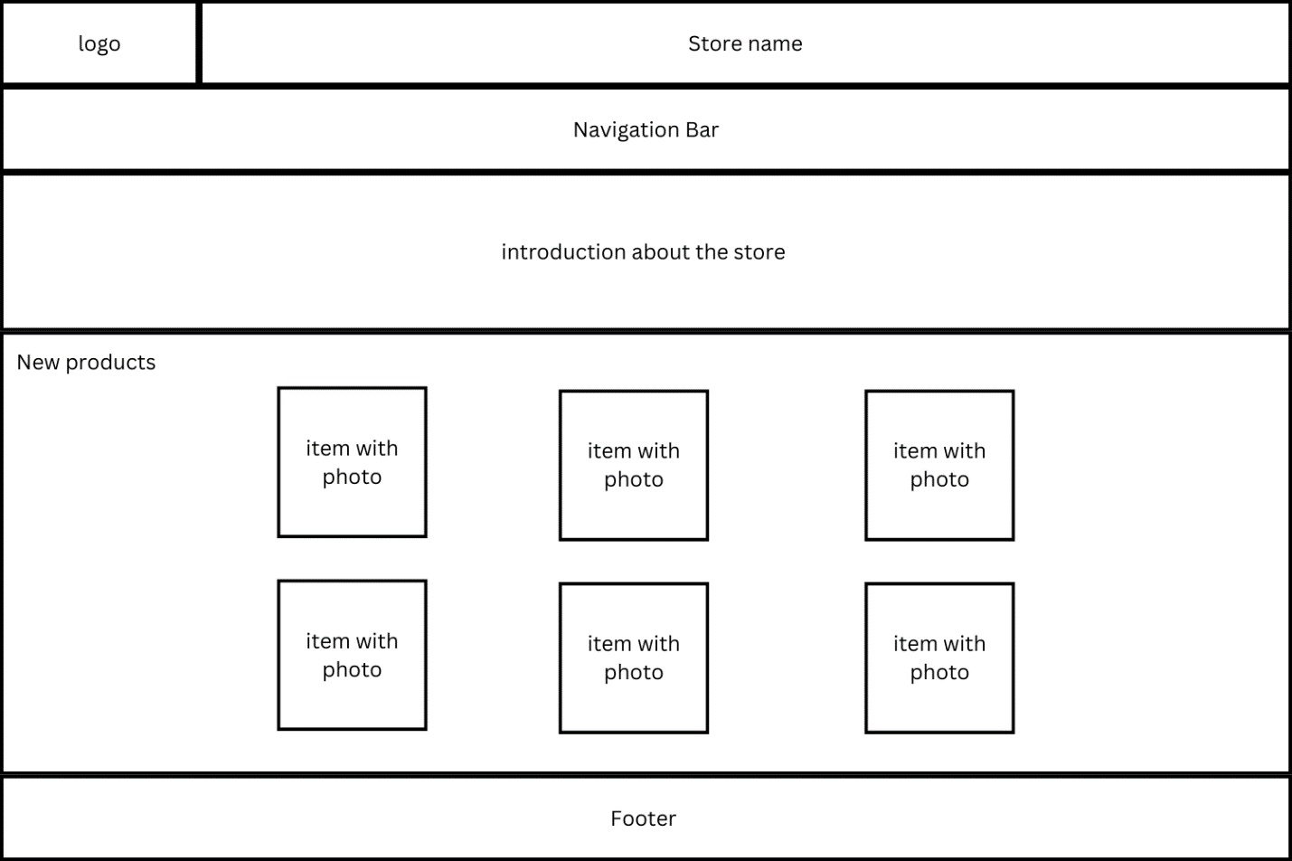

Services Page

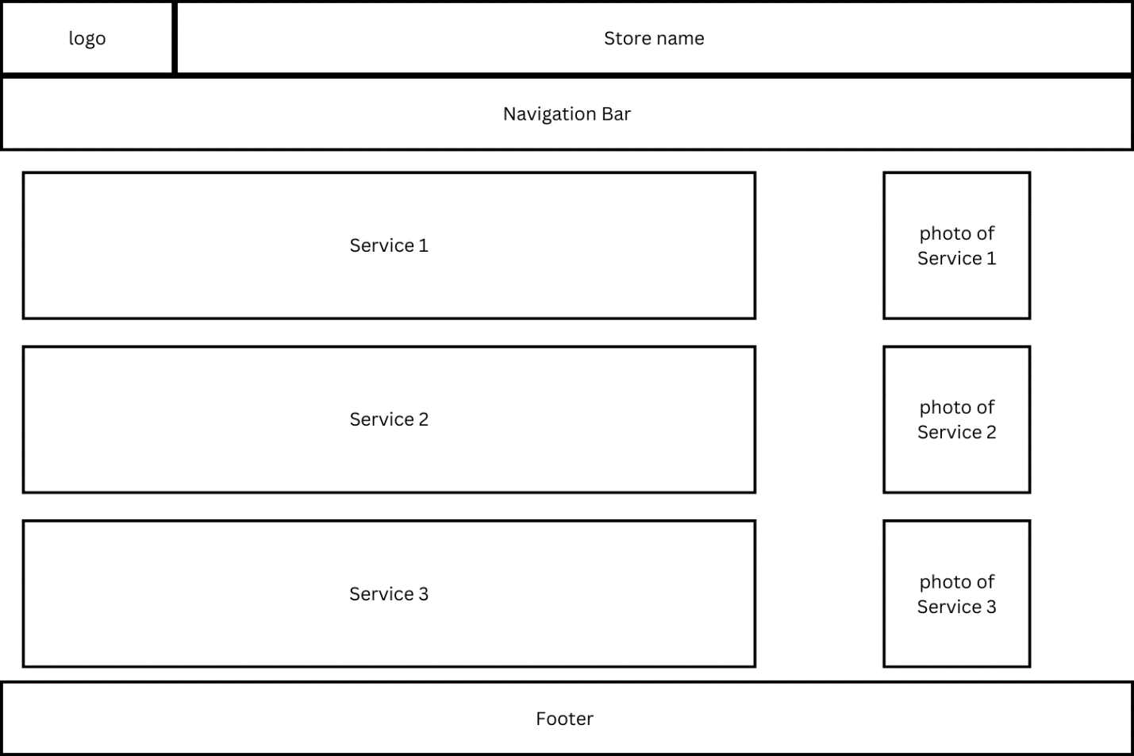

Products Page

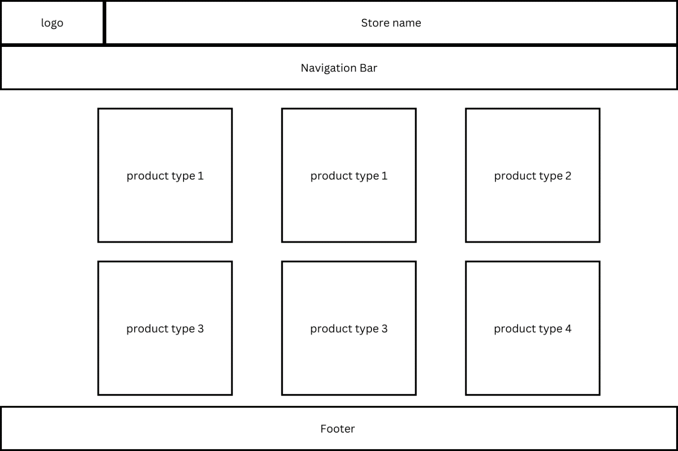

About us page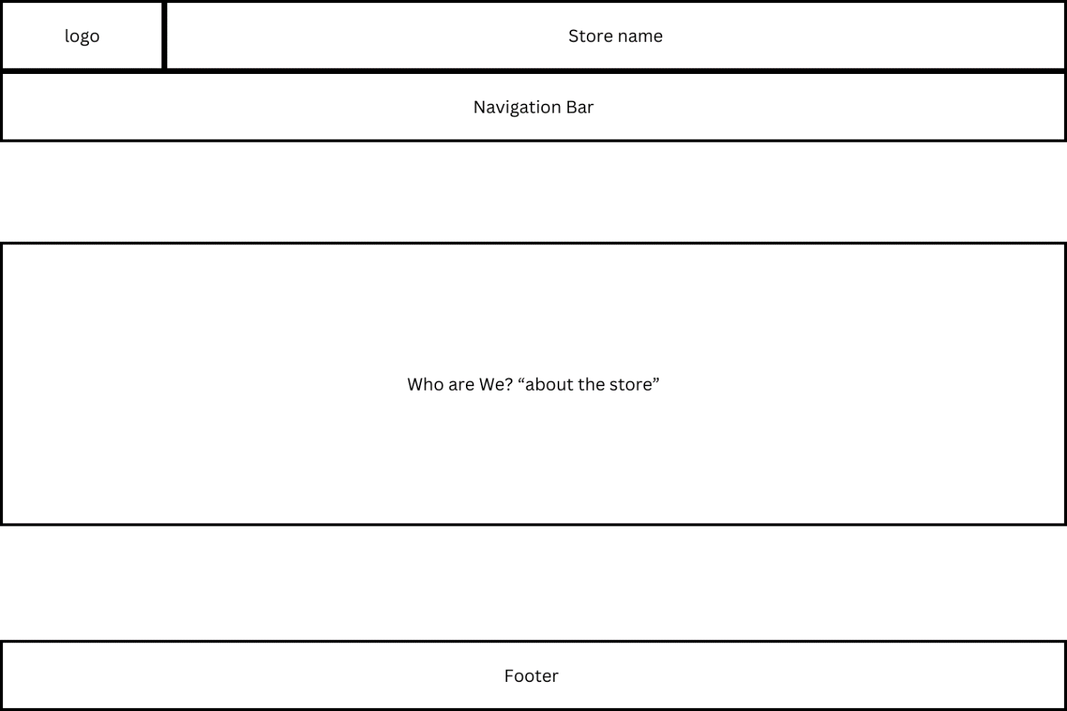

Contact Us Page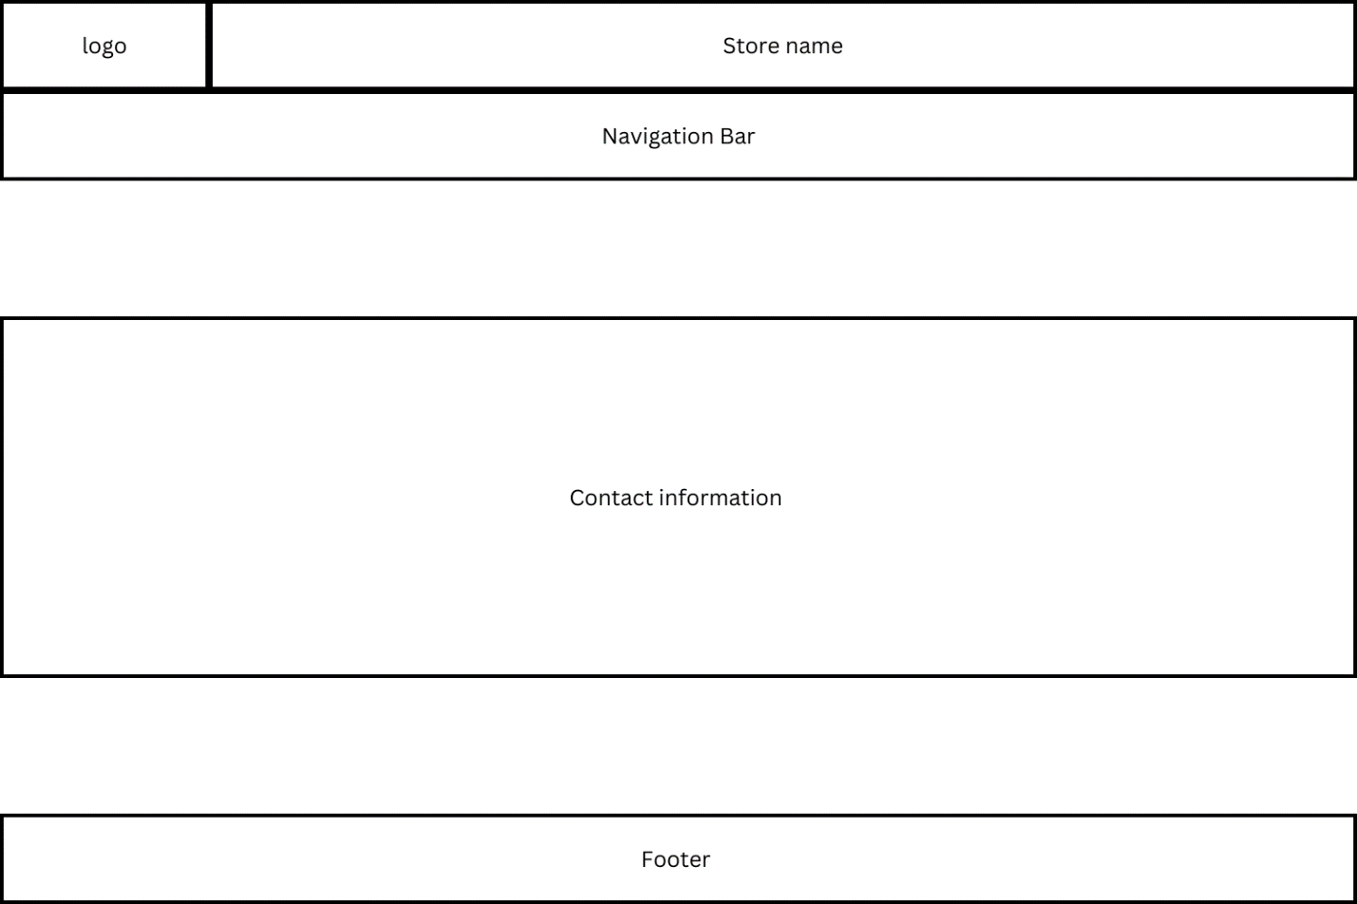

sign up form page

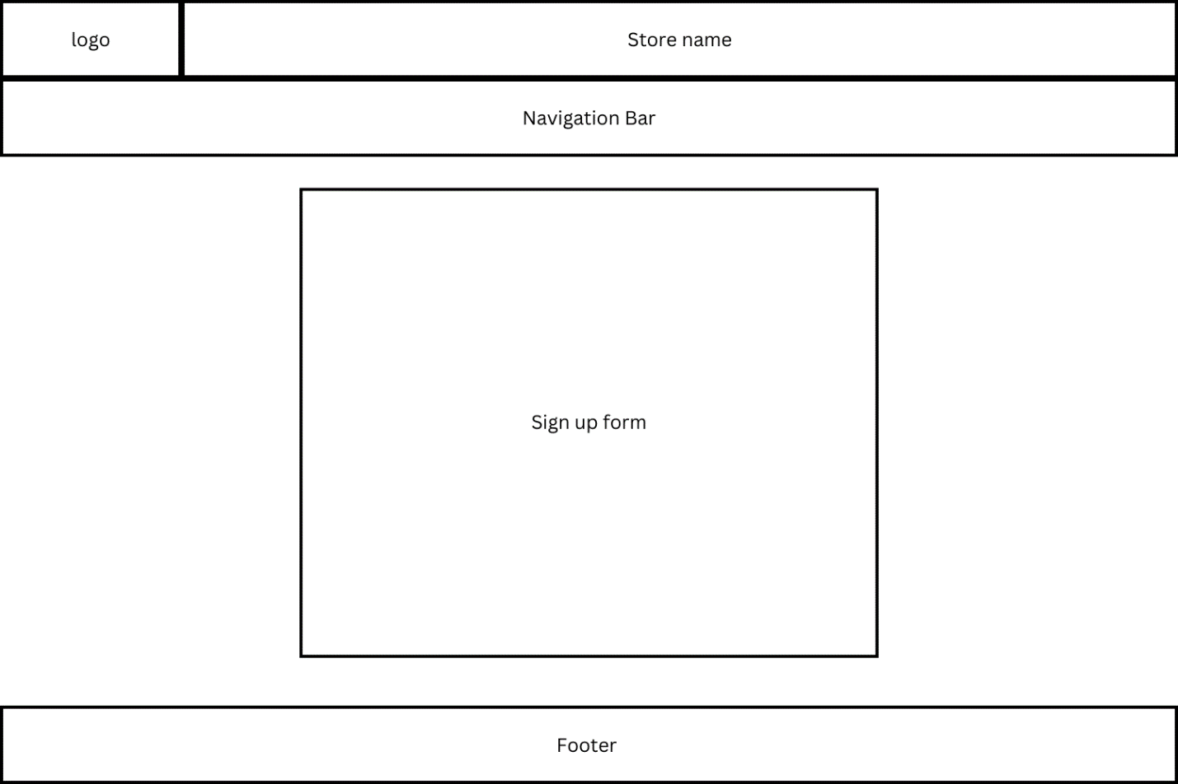

Product Details Page

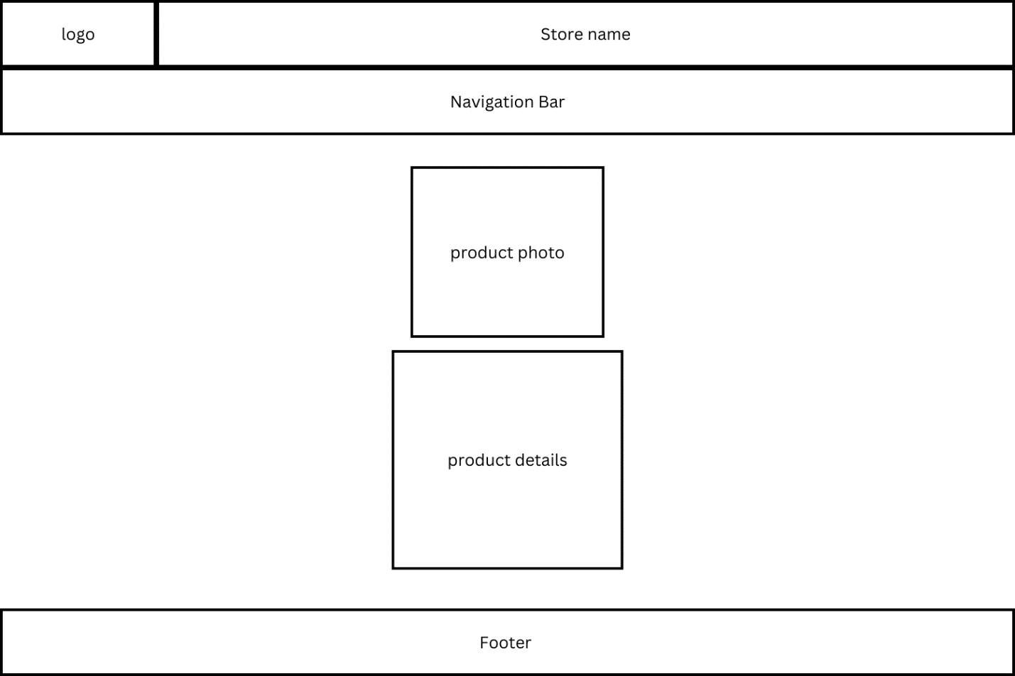

Cart Page

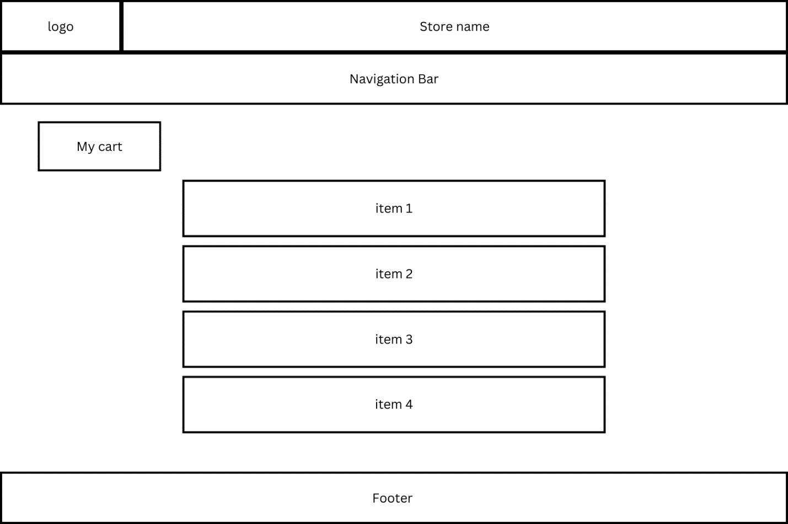

Sitemap

